Кибасова Насима Танжариковна
Ағылшын тілі пәні мұғалімі
Маңғыстау облысы Мұнайлы ауданы
№1 орта мектеп
Grade: 9
The theme of the lesson: Unit 7. Mass media. Step 1. Mass media
The aim of the lesson:
Educational: to enlage student’s knowledge on the theme, to enrich students’ lexicon through
new vocabulary.
Developing: to develop students’ speaking, reading and retelling skills.
Bringing up: to teach expressing-the opinion, to give more information about mass media
The type of the lesson: combined
Inter-subject connection: Kazakh language
Methods of teaching: explaining, showing.
The equipment: an interactive board, cards, stickers, pictures and the texts about mass media
Literature: English textbook by Ayapova.
The procedure of the lesson:

I. Organization moment:
a) Greeting.
Teacher: Good morning, boys and girls! Nice to meet you! How are you?
Pupils: Good morning, teacher! We are fine, thank you!
b) Marking of the absentees
II. Checking up the home task
Exercise 3. Read the text and answer the questions in pairs.
- Who was the first theatre established by?
- What makes the Globe the most famous theatre?
- How did people watch the performances?
- Why were the costumes luxurious?
- What did you learn about the actors of the past?
III. The theme of our lesson is «Unit 7. Mass media. Step 1. Mass media»
1. Speaking
Brainstorming:
Answer the questions in pairs first, then have it as a class..
How many hours a day do you spend
reading books?
watching TV?
listening to radio?
surfing the Net?
Which of the media do you consider the most reliable source of information?
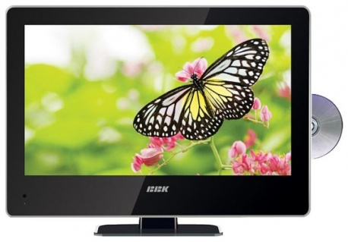
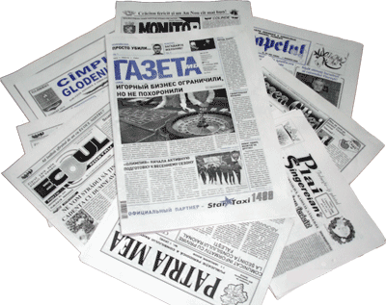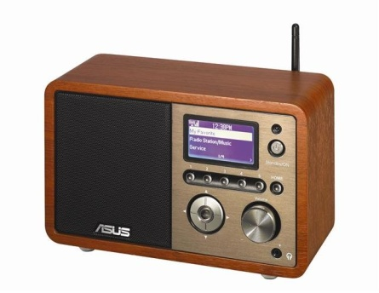

Are you satisfied with the quality of newspapers?
TV programmes?
radio programmes?
New words:
Mass media, interpersonal media,
Reading
Exercise 2 Read the text and answer the questions
Mass media
Mass media includes all the “tools” we have for communicating with large numbers of people… televisions, radio, films, on-line services, magazines and newspapers. All carry messages that reach masses of people in contrast to letters, telephone calls and one-to-one conversations known interpersonal media
The mass media refers to the people and organizations that provide news and Information for the public. So far, these were mainly newspapers, television, and radio. Today computers play a very big role. The Internet is a computer system that lets people receive and exchange information about anything. Ordinary post has been taken over by e-mail which stands for electronic mail because it is sent and received via a computer. It allows people to send messages to each other quickly and cheaply. Ordinary post is now called “snail male” and one wonders if the postman’s is a job under the threat of extinction.
IҮ. Work in pairs
Questions for student A pg. 155
- What images come you to mind when you hear the word “media”?
- What is the media?
- Do you think the media have too much power?
- What are the good and the bad things about the media in your country?
- Do you always believe the media?
- How is the today’s media different from that of 30 years ago?
Questions for student B.
- Would you like to work for the media?
- What do you think of the mass media?
- Why do people hear the media?
- Do you think the media tries to change people’s views?
- Is it a good idea for a country’s media to be controlled by the government?
- Do you trust the media?
Exercise 3 Read and try to use them
Opinions, Preferences:
I think…, in my opinion…, I’d prefer…, As far as I’m concerned…
Disagreeing:
I don’t think that…, don’t you think it would be better…, I’m afraid I don’t agree…
Ү. Discussing
Exercise 4. Inventions and overweight children
VI. The Ending of the lesson:
1.Conclusion.
2. Home task: Exercise 4 page 155.
3. Marking
Our lesson is over. Good bye!

